1930’s and Escapism
Essential Question:
The great depression: 1929 – 1939
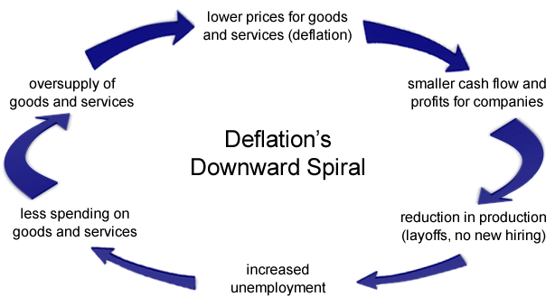

What would you do?

Dorethea Lange:

Photo Analysis/Reaction: How do these photographs represent the 1930s? What themes do these photographs explore or what emotions do they evoke? How might these photographs have impacted the 1930s and its aftermath?
Reaction to: Fast Food Line Distribution-

Reaction to: “Thirteen million unemployed”.

Overview
Parts of the Picture
Title
Inter-relationships
Conclusion
Optic - Migrant Mother
Woody Guthrie Bio Notes

“This Land is Your Land” TPCASTT Analysis
Title: Examine the title of the poem | This Land Is Your Land  Words and Music by Woody Guthrie  This land is your land This land is my land  From California to the New York island;  From the red wood forest to the Gulf Stream waters  This land was made for you and Me.  As I was walking that ribbon of highway,  I saw above me that endless skyway:  I saw below me that golden valley:  This land was made for you and me.  I've roamed and rambled and I followed my footsteps  To the sparkling sands of her diamond deserts;  And all around me a voice was sounding:  This land was made for you and me.  When the sun came shining, and I was strolling,  And the wheat fields waving and the dust clouds rolling,  As the fog was lifting a voice was chanting:  This land was made for you and me.  As I went walking I saw a sign there  And on the sign it said "No Trespassing."  But on the other side it didn't say nothing,  That side was made for you and me.  In the shadow of the steeple I saw my people,  By the relief office I seen my people;  As they stood there hungry, I stood there asking  Is this land made for you and me?  Nobody living can ever stop me,  As I go walking that freedom highway;  Nobody living can ever make me turn back  This land was made for you and me.
Paraphrase: Translate the poem into your own words

Connotation: Examine the poem BEYOND the literal

Attitude: Examine the speaker’s and the poet’s attitudes (also called “tone”)

Shifts: Note shifts (changes) in speaker, attitudes, rhetorical stance. Look for change in sentence structure

Title: Examine the title of the poem again

Theme: List what the poem is about (subjects) then ID what the poet is saying about these subject (themes)

What qualities in the lyrics of Guthrie’s song convey his life experiences?

Why do you think he wrote the song and performed it?

What does the song tell you about life and experiences during this period?

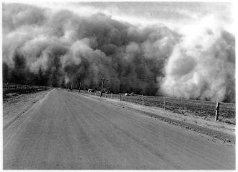
Dust Bowl Ballads
Choose a Guthrie song and determine its meaning by listening to it and viewing the lyrics. https://genius.com/albums/Woody-guthrie/Dust-bowl-ballads
Create an album cover for the single release of this song that demonstrates its meaning.
Requirements
Front: Image that captures Guthrie’s message in this particular song (should be aesthetically appealing & engaging!)
Back: Analysis paragraph explaining
- Your understanding of Guthrie’s song
- Its connection to history
- Its purpose
(6-8 sentences, should quote the text)
Answer about Guthrie songs in general:
- How do these song or the style of music exemplify the era?

- What emotions and themes do you hear in the music and the lyrics?

- How would you define this era, according to the music?

John Steinbeck Notes

Grapes of Wrath

Migrant Workers
Grapes of Wrath Jigsaw My chapter # ________ My Partner_________________________
You and a partner are responsible for becoming experts on one of Steinbeck’s intercalary chapters. You are each individually responsible for critically reading your chapter and answering the following questions:
Individual Question:
  - How would you describe Steinbeck’s style?
  - What is this chapter about?
  - How are the themes of this chapter similar or different to other texts we have read in this class?
  - Why do you think Steinbeck included this chapter?
Partner Questions: Discuss the chapter you read, make sure you have the same understanding of what the chapter is about.
- What are the power dynamics represented within the chapter you read? What drives this power (or powerlessness)?

- What was your emotional response to the chapter you read?

- How does Steinbeck’s style contribute to the message of the chapter you read?
- If you were to title this chapter, what would you call it, and why?

Large Group Jigsaw
- In your groups, take turns teaching each other about the chapters that you read. Discuss the ways you answered the previous questions.
- For each jigsaw piece, title each chapter and fill the puzzle piece with the essential information about each chapter (it is up to you to determine what this is)

As a whole group create an analysis statement about what you think Steinbeck’s purpose with the Grapes of Wrath of is? Is he successful?

Movie Clip Analysis
Clip 1 (36-46:15)
- What do you notice about their journey?
- Who was affected?
Clip 2 (1:05-1:11)
- Were conditions in the migrant camps better than back in Oklahoma?
- What is the ‘agitator’ trying to do? Why?

Reflection on the Novel/Film
- What did you notice about life for migrant workers?
- What connections can you make to the lives of immigrant workers we discussed during the progressive era? (As there more similarities or differences?)
- What is the attitude of these workers?

Final Question
Guthrie, Lange, and Steinbeck are all expressing frustration at the state of the country and the government’s inability to step in and make effective changes – is this fair? Why or why not?

1930s Escapism and Film
The Golden Age of Hollywood
Why do we need the arts?

1930’s Hollywood

Charlie Chaplin

Modern Times

Jot down notes that will help you discuss these with the whole class:
- What is Chaplin’s film about? How do you know?

- What historical connections can you make?

- How does Chaplin get his message across without necessarily using the spoken word?

- Why do you think audiences would have enjoyed this?

What do you know about the Wizard of Oz?

Cultural Significance

Reflections:
How are the themes addressed in the Wizard of Oz similar or different to what you saw in Charlie Chaplin?

How are these ideas communicated differently? Is this more or less effective than Chaplin?

Superman Comics:
Notes:

How is reading images similar or different to reading text? What becomes important?

What do you notice about the message of this comic? What is Superman being used to do?

1930s and Escapism Culminating Project

After looking at the wide variety of 1930s artists, your task is to create an original work that reflects a connection between the literature and attitudes of the 1930s and America today.

Requirements: Project and typed rationale (approximately 150-200 words)

- Potential Escapism mediums:
  - Comic book
  - Recorded song (send Ms. Havlin youtube link)
  - Photo journal + accompanying reports (must be original)
  - Short story vignettes
  - Short film (send Ms. Havlin youtube link)
  - Got another creative idea? Let me know!
ALL work that is not your own (most, if not all, of the project should be your own work) MUST have a works cited. No works cited = no credit.

- Grading:
  - 10 pts creativity and presentation
  - 10 pts analysis/depth of understanding displayed
  - 10 pts rationale explaining how your project clearly demonstrates understanding of the historical context and connection to today

 | Standard (10 pts) | Approaching Standard (8-9) | Below Standard (6-7)
Creativity and Presentation | Unique submission; integrates message with chosen medium; clear and professionally presented (aesthetically pleasing) | Creative submission; somewhat integrates message with chosen medium; attempt is made to present project in an aesthetically pleasing manner | Unoriginal submission; unclear how the medium matches the intended message; lacks aesthetically pleasing visual presentation
Analysis (depth of understanding displayed) | Project demonstrates a specific point of view regarding historical context and an aspect of American society today; project demonstrates great depth of analysis and understanding | Project demonstrates broad understanding of historical context and an aspect of American society today; project demonstrates surface level analysis and understanding | Project fails to show an understanding of either the historical context or an aspect of American society today; or analysis is confusing
Rationale | Rationale clearly explains specific connections between historical context and America today present in the project | Rationale lacks some clarity; makes broad connections between the historical context and America today contained in the project | Rationale is confusing, or does not clearly show a connection between the project, the historical context of the 1930s and today

