Crucible Packet 2016
Ms. Havlin, American Literature
Major Assessments of Learning:
Packet work, reading quizes (one per Act), multiple choice & short answer test, creative project

Monday | Tuesday | Wednesday | Thursday | Friday
3/14 | 3/15 | 3/16  Background Info | 3/17 | 3/18
3/21 | 3/22 | 3/23 | 3/24 | 3/25
3/28 | 3/29 | 3/30 | 3/31 | 4/1
4/4 | 4/5 | 4/6 | 4/7 | 4/8

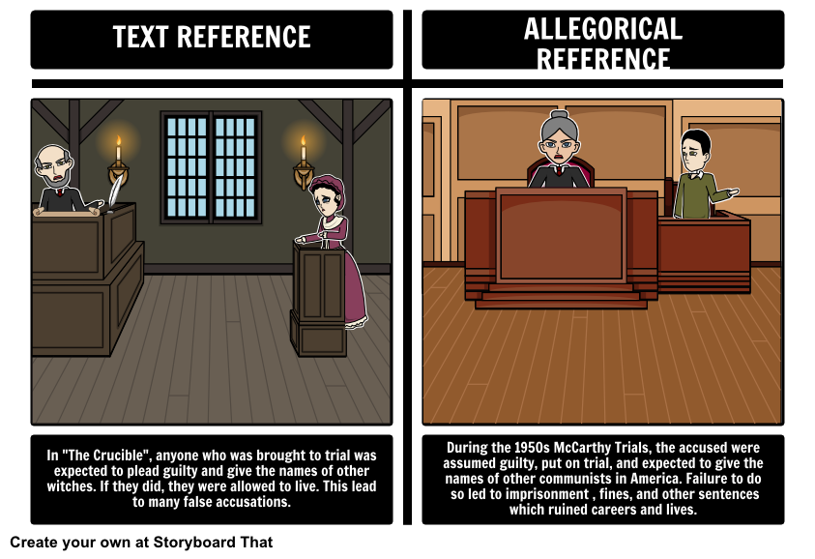

Text Reference | Allegorical Reference
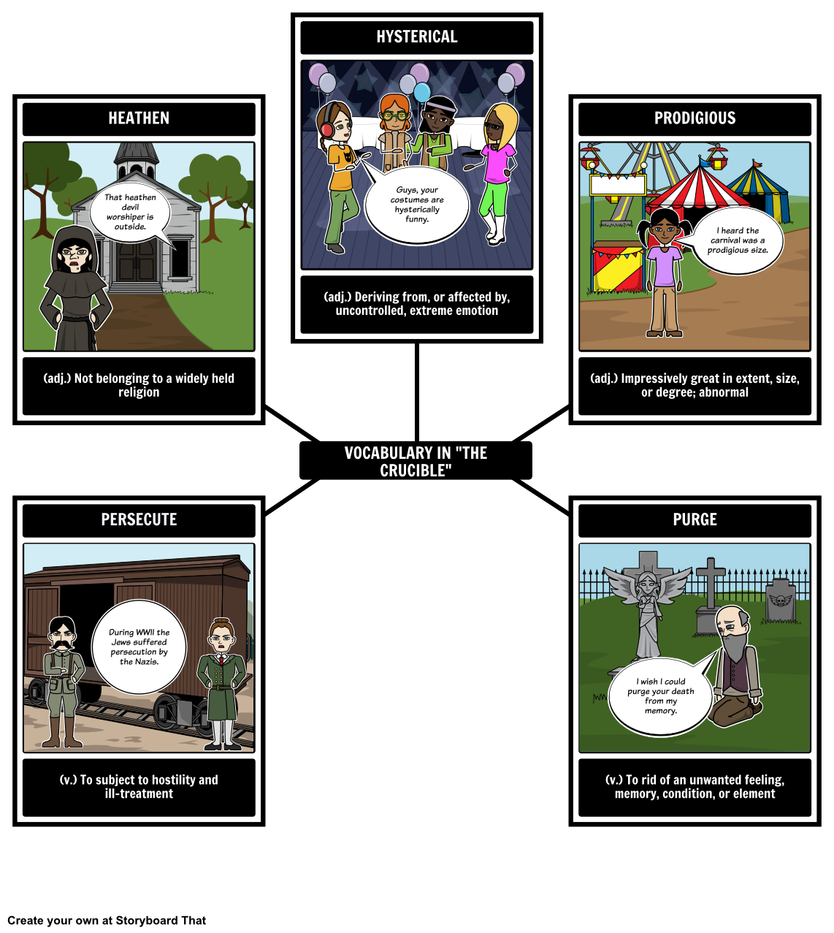
Quote/Event:

Quote/Event:

Quote(hysterical):

Quote/Event:

Quote/Event:

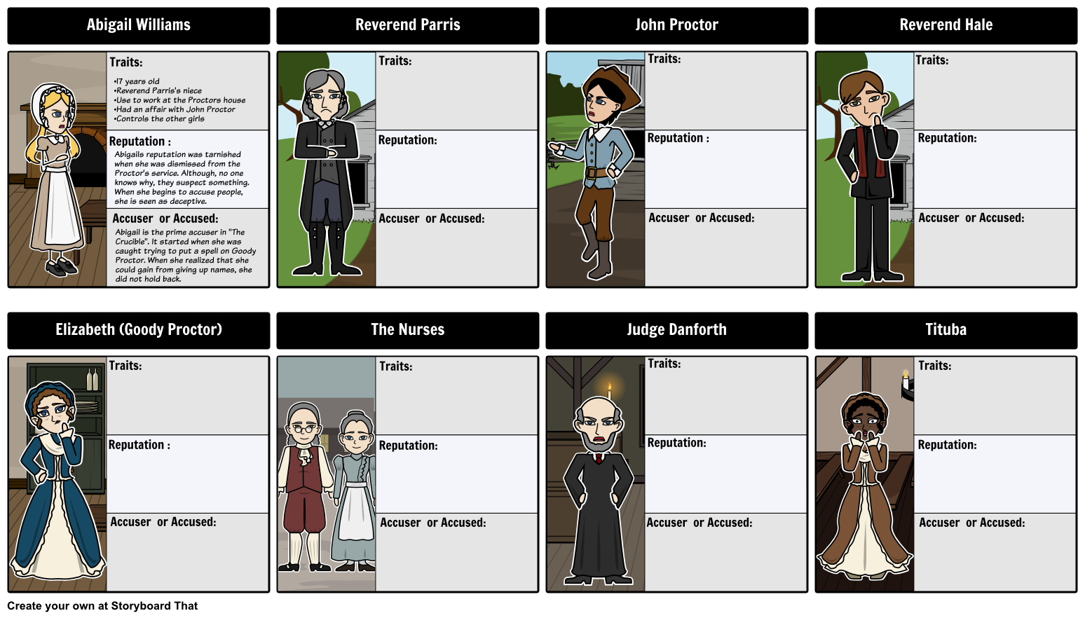
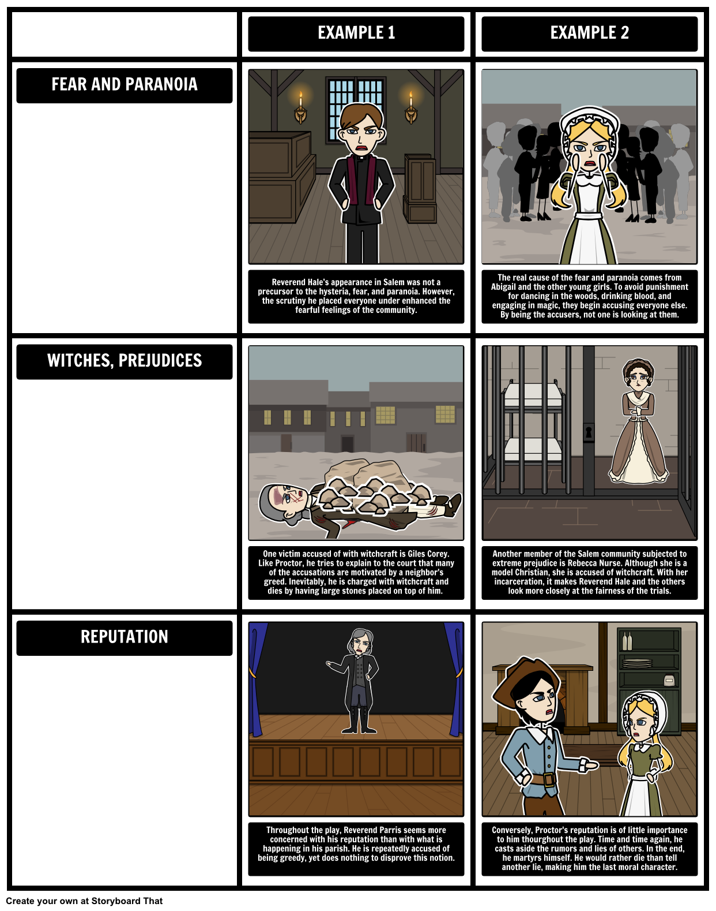
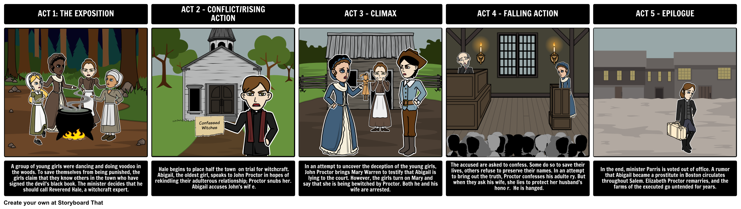
Quotes/Events ACT 1 | Quotes/Events ACT 2 | Quotes/Events ACT 3 | Quotes/Events ACT 4 | Quotes/Events ACT 5

