Dotson' Sa, Great Raven Makes the World
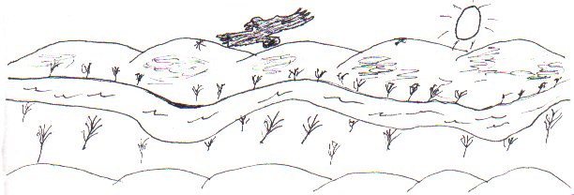

A very, very long time ago, giant animals lived in the world and there was no such thing as mankind. They were all big and could talk to each other and use magic. There were even some animals which no longer live on earth. One day Dotson' Sa, Great Raven, said to Raven, "Make a large raft."

So Raven made a large boat. It took a long time because it had to be very big. When Raven was finished, Dotson' Sa told him it wasn't big enough.

"You must build it bigger." he said.

When it was finished, it began to rain. At first it rained only a little and Dotson' Sa instructed Raven to gather all of the animals in pairs. Raven gathered the animals and food for them. It was very difficult but he did it anyhow.

Once all of the animals were on the raft, it started to rain very hard. The whole world was soon flooded and only those animals on the raft were left in the world.

When it stopped raining Raven asked some seagulls to fly in every direction in search of land. They flew away and returned saying how there was no land in sight. There was only water!

After a while the flood was almost gone. Raven told Muskrat to swim down to the ocean floor to make an island. The muskrat, who was really quite large, dived down and started piling up the mud from the bottom. He kept this up until land appeared.

Dotson' Sa used his magic and made berries, trees, and plants to cover the land. When he had done this, lakes and ponds were left where there had been low spots in the land. Next, Great Raven made rivers. He made them so that they flowed both ways! On one side the river ran down to the sea, and on the other it flowed up towards the mountains!

Later, though, he decided that it was too easy to travel and so he made it so that rivers only went down to the sea.

Now that the flood was gone and there was land, Dotson' Sa decided to make man. He created him from stone but because he was made of rock, man would never die and so Great Raven decided to make him from clay instead.

After he had made man, he made woman so that they could be married and have children. Raven wanted a wife so he tried to marry one of the women but the men took her away from him. This made Raven mad, so he took some dried leaves and crushed them into a large bag. He took the bag and went to where the people lived and opened it. Out flew millions of mosquitoes which still pester and bite mankind because Raven wasn't allowed to marry a woman.

Now Raven had created the whole world. That is why he is never hunted because he made everything.

