Edgar Allan Poe Group Projects

The purpose of this assignment is to teach the rest of the class about your story. Your projects should be done as a cohesive group and help not only to tell the story, but also demonstrate how Poe uses imagery and setting to express the tone and mood of the story.
Each group will receive one of 5 additional Poe stories that we have not read in class. You will each need to read the story and come up with a creative way to retell it (think Tim Burton). This can be anything from a comic strip, to a puppet show, to Claymation, to an animated short film or trailer… whatever you choose, select something which highlights your talents and maintains a high level of professionalism (well-rehearsed, quality drawing, excellent editing, etc). You will have two full class days to work on your project, but the rest will have to be done as homework. We will present these in the form of a gallery walk in class on Tuesday. If you need to attach a written explanation of your presentation piece to meet the requirements of the rubric, please do so!
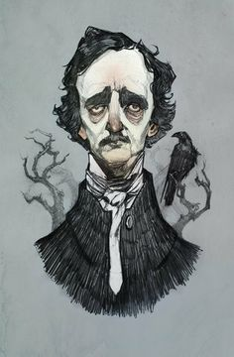

Poe Short Stories:
- The Black Cat
- The Cask of Amontillado
- The Pit and the Pendulum
- Berenice
- The Fall of the House of Usher

CATEGORY | 4 | 3 | 2 | 1
Content - Accuracy | All content throughout the presentation is accurate. There are no factual errors. | Most of the content is accurate but there is one piece of vital information that might be inaccurate. | The content is generally accurate, but some of the interpretation of the storyline is clearly flawed or inaccurate. | Content is typically confusing or contains more than one factual error.
Interpretation demonstrates understanding of rhetorical devices  (x3) | Elements of dark romanticism are clearly demonstrated. Tone and mood are clear to the audience through strong interpretation of setting and imagery. | Mostly clear demonstration of tone and mood through interpretation of setting and imagery, some pieces may be unclear. | Some information is clearly interpreted. Setting or imagery is not clear enough to demonstrate tone or mood. | There is no clear demonstration of the understanding of tone and mood through imagery and setting.
Creativity/  Originality (x2) | Presentation shows considerable originality and inventiveness. The content and ideas are presented in a unique and interesting way. | Presentation shows some originality and inventiveness. The content and ideas are presented in an interesting way. | Presentation shows an attempt at originality and inventiveness on 1- 2 cards. | Presentation is a rehash of other people's ideas and/or graphics and shows very little attempt at original thought.

Total: 24 culminating points

