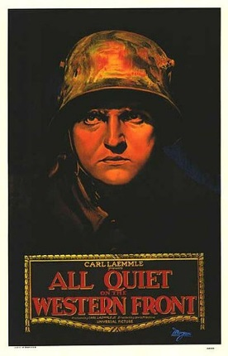
Graphic Novel of All Quiet on the Western Front

- Groups of 3 ____________________ ___________________ __________________
- List the most important events from section

- List the most prevalent emotions from the section
- What were the strongest places of visual imagery?

- What theme was portrayed in this section?

- Write a thesis statement for your section (how = literary technique, what = content, so what = impact/developed idea about the theme)
- Graphic Novel Requirements (not a comic strip. This is different):
  - Minimum 15 panels, 3 different types of panels
  - Minimum 10 gutters, 3 different types of gutters
  - Minimum 5 balloons, 3 different types of balloon
  - Strong sense of design – sketch your ideas first, then begin the final product
  - Demonstration of important events, emotions, and theme
  - One paragraph explaining theme demonstration
  - One paragraph explaining panel, gutter, and balloon choices
Over
Suggested Plan of Action
- Decide how to organize the sequence of events
- Match the panels to the events
- Draft a “stick figure” version of the panel sequence
- Ask: Have we met the minimum requirements? Have we demonstrated theme?
- Begin drawing and writing (this is why you have a group ).
Draft of panel sequence

