Macbeth Creative Project
All creative projects must include 1. justification paper AND 2. creative element.
This grade is culminating in both LA and SS gradebooks. Notice that you need to include a historical connection in the creative element AND justify the connection.
Have an idea of something else? Come talk to Ms. Havlin before _____________
Option | Creative Element Min. Requirements | Paper Requirements | Final Copy
Movie or  Play Poster | - Two symbols  - One theme  - One quote  - historical connection | Connection and justification of requirements and creative choices. | Printed or hand-drawn (must have skill)
Acting/ Movie | - Two symbols  - one theme  - two quotes  - historical connection  Maximum four people in a group. Every actor needs an equal part. | Individual Connection and justification of requirements and creative choices. | Present in class  OR movie presented in class
Sound-track | - Two symbols  - Two themes  - historical connection  - Min 10 songs | Connection and justification of song choices, requirements and organization. | CD or  Electronic Link
Song or Poem | - Two symbols  - Two themes  - Two quotes  - Historical connection  - Min 25 Lines | Connection and justification of requirements and creative choices. | Song –  CD or  Electronic Link  Poem - Printed
Creative choice! | - Two symbols  - Two themes  - Two quotes  - Historical connection | Connection and justification of creative choices, symbols, themes, and historical connection. | Talk to  Ms. Havlin about ideas!
Brainstorm:

Creative Project Rubric: Name ____________________________________________ Project _____________________ SCORE: _______/60
Submission: Bring creative element to class in format stated in the options.
Staple this rubric o printed justification paper. Then, attach the packet to the pack of your project.
- Justification Paper (20 points):
- Minimum Requirements: One page, double space, one inch margins, 12 point font, times new roman. 2 paragraphs.
- Commentary and Connection: Does your paper clearly connect your creative element to a theme/main concept?
Is your commentary relevant and helpful to the connection? Does the reader grasp a better understanding of your creative project? How do the history and literary connections go beyond the surface level connection?
- Organization: An organization structure is clear. Thoughts/connection/commentary proceeds in a logical manner from the beginning to the end of the paper. At least two paragraphs
 | Exceeds Standard (A) | Meets Standard (B) | Approaching (C) | Does not meet Standard
Minimum  5 Points | Goes beyond stated requirements | Meets minimum requirements as stated above. | No more than 2 elements are incorrect | More than 2 elements are correct or missing
Commentary  Connection  10 Points | Always relates and is relevant. Aids the readers understanding of the project. Ideas are always connected to a bigger picture, theme, symbol, history, etc. Connections are strongly supported | Mostly relevant. Almost always relates. Ideas are almost always connected. Connections are almost always strongly supported. History connection present. | Somewhat relevant.  Sometimes relates. May need to revisit history connection. | Is not relevant, does not relate.
Organization Grammar  Conventions Spelling  5 Points | Excellent flow, no errors | Some awkward wording. Minor error or two | Prevalent errors. Some choppy sentences. | Errors throughout. Hard to follow train of thought.

- Creative Component Requirements (40 Points):
- Minimum Requirements: All requirements stated in the description.
- Effort – I do not expect you to have exceptional artistic ability, but I do expect you to choose something that will highlight your abilities. (Clean/straight lines, erased pencil marks, neat paper, type vs. handwriting, color printing).
This way I can fairly grade you on the effort you put toward the creative component.
- Creativity - Making a creative connection the text. Shows me you understand the text on a deeper level then what we have discussed in class.
 | Exceeds Standard (A) | Meets Standard (B) | Approaching (C) | Does not meet standard
Minimum Reqs  10 Points | Goes beyond minimum | Sticks to minimum | Missing half of the keys elements | Missing more than half of the key elements
Effort  15 Points | High level of care/effort went into the making of the art. Presentation of work is neat & seamless. No areas for improvement. | Moderate level of care/effort. Presentation of work is neat/ seamless. Few areas of improvement. | Many errors, little care/effort went into the work | Work is sloppy, no care/effort seems to be put into the work
Creativity  15 Points | Illustrates excellent understanding in a creative manner. Goes beyond class discussion. Historical/Literary connection exemplary. | Illustrates a good understanding of the play in a creative manner. Connection to history is strongly present. | Demonstrates understanding of the play but does not reach beyond to make a creative connection. | Little to no demonstration of creativity present or demonstration of comprehension
Semester I Language Arts Formal Literary Analysis Essay:
- MLA Format: 12 Point, Times New Roman Font. 1 inch margins. MLA Heading & running header
- 700 – 900 words
- 2nd Draft Submitted for FULL grading (write it as if it were the final)
- Final Draft AND annotated revision submitted for final grade.
- The grade for this essay will go into both LA and SS gradebooks.

- Macbeth Essay Prompt Choices (Select One) -
- Macbeth is one of Shakespeare’s most dynamic tragic heroes. Analyze his character. (You can think about the significance of his experience, what he represents, examine his mental deterioration, etc.).

- Lady Macbeth is one of Shakespeare’s most powerful female characters. Analyze her character. (You can think about the significance of her experience, what she represents, her influence on her husband, her attraction to the supernatural, etc.)

- Analyze the relationship of the Macbeths. Consider how it changes throughout the play and how it is used to develop a thematic message. Consider critical lens theory.

- Trace Shakespeare’s use of one of the following images/motifs (blood, sleep, dreams, hands, milk, birds, stars, or night) and explain the significance of that image.

- Analyze the significance of the paradox “Fair is foul and foul is fair …” in the play.

- Select one of the following topics and identify a related theme inherent in the text. Show how it is illustrated and developed through Shakespeare’s use of a dominant literary convention (ex. imagery, metaphor, motif, irony, personification, symbolism, etc.)
- Power
- Ambition, Guilt, and Fear
- Deception
- War
- To what extent does Macbeth’s duality between his internal and external persona cause his violent actions throughout the play?

- How do characters’ fears emerge through dreams and visions during the play? What do these visions reveal about the characters? How does this motif relate to an overall theme?
- Other ideas? Come see your teacher!
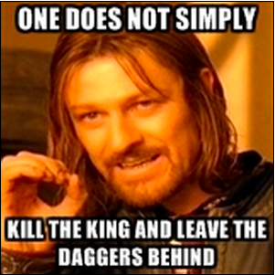
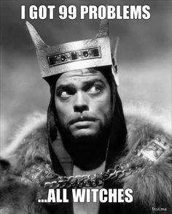
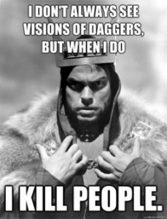
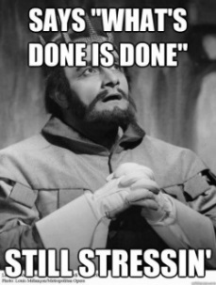
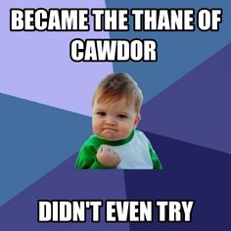

Macbeth End of Unit Calendar
11/12  No School – Veteran’s Day | 11/13  Act 5. Scene 8  Review | 11/14  Writing Time Wednesday/Review | 11/15  Macbeth Test  Packet DUE | 11/16  Writing time
11/19  Outline #1 DUE  (8am turnitin.com)  Peer edits & Writing Time | 11/20  Outline #2 DUE  (8am turnitin.com)  Writing Time | 11/21  Writing Time | 11/22  Thanksgiving | 11/23  Sleepy Time
11/26  Draft #1 DUE  (8am turnitin.com)  Peer Editing, Conferences,  Writing Time | 11/27  Writing Time | 11/28  Draft #2 DUE  (8am turnitin.com)  Peer Editing, Conferences,  Writing Time | 11/29  Conferences  Project work time | 11/30  Peer Editing  Conferences  Project Work Time
12/3  Conferences  Project work time | 12/4  Creative Project DUE | Final Draft Due Dates  Annotated Revisions Copy + Graded rubric - DUE 12/10 – In-class  Clean Copy of Final Draft - DUE 12/10 - Turnitin.com 8am
Final Draft Requirement
- Write your 2nd draft as if it were the final! Every student who submits a 2nd draft will receive a fully graded draft and score.
- If you met standard on thesis & analysis, you have the choice to keep the 2nd draft score or submit an edited final draft + revision protocol.
- If you did not meet standard on thesis & analysis, you are required to submit a new draft with edits to these areas. You may also edit other areas, indicate on annotated copy.
Revision Protocol:
- Answer the following questions on the back of your graded rubric:
  - What were your strengths on this writing assessment?
  - What writing skills or techniques do you need to focus on before submitting a revision?
(Be specific to the category and HOW you plan to revise)
  - What are your analytical writing goals for the next essay and what progress have you made thus far in achieving them?
- Begin revising your draft. I suggest having two documents up so you can see the original.
- Turnitin.com: Submit revised copy to turnitin.com.
- In-class: Submit graded rubric + answers to questions on the back of the rubric + printed, annotated revised copy. (Annotated Revised Copy= highlight all changes and write how you revised that area on the printed copy.)

