Guided Studies Name:
Note Taking Strategies

The Mapping Method

Why is it useful?

One Advantage:

The Outlining Method

How is it useful?

One Advantage:

The Charting Method

It is Useful Because…

One Advantage:

The Sentence Method

This is helpful when…

One Advantage:

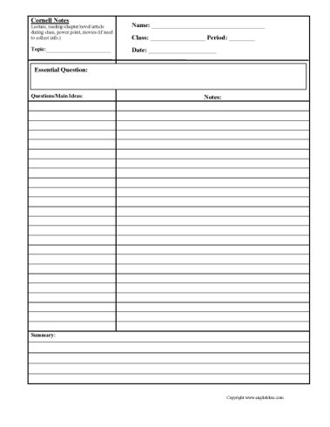

Cornell Notes

UBER Organized!!!!

An Advantage:

