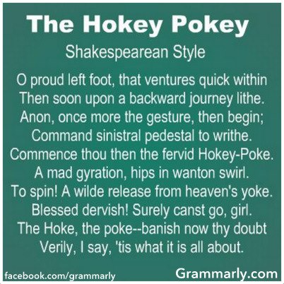
Sonnet Recitation!
Justification (in case you’re curious): A culminating piece for eye contact and word emphasis. Practice for confidence and nerves. Practice with a subject which may not be your favorite (I promise, this does happen in real life).
- Select a Shakespearean Sonnet (there are 154 to choose from!)
- Make sure it is one you can mostly understand and has words & phrases you love.
  - Read it at least 5 – 10 times before making a final decision
  - Make sure at least three of those readings are out loud
- Print two copies, double space
- Annotate copy #1 for meaning
  - These annotations are for you to discern occasion, audience, and purpose before annotating for speech emphasis.
- Annotate copy #2 for speech emphasis
  - Use a symbol system AND annotations. (be specific)
    - Gestures, Movement, Vocal Variation
  - Select two favorite places in the text and write one paragraph each justifying your emphasis choice. Make the link between text and emphasis clearly intentional and thoughtful.
- Memorize!
  - Tip: rewrite the sonnet in sentences or sections that make sense to you. Then memorize those chunks.
  - After memorizing the sections, memorize with emphasis.
- Recite in class on Monday & Tuesday (random order disclosed day of recitations)

Sonnet Recitation!
Justification (in case you’re curious): A culminating piece for eye contact and word emphasis. Practice for confidence and nerves. Practice with a subject which may not be your favorite (I promise, this does happen in real life).
- Select a Shakespearean Sonnet (there are 154 to choose from!)
- Make sure it is one you can mostly understand and has words & phrases you love.
  - Read it at least 5 – 10 times before making a final decision
  - Make sure at least three of those readings are out loud
- Print two copies, double space
- Annotate copy #1 for meaning
  - These annotations are for you to discern occasion, audience, and purpose before annotating for speech emphasis.
- Annotate copy #2 for speech emphasis
  - Use a symbol system AND annotations. (be specific)
    - Gestures, Movement, Vocal Variation
  - Select two favorite places in the text and write one paragraph each justifying your emphasis choice. Make the link between text and emphasis clearly intentional and thoughtful.
- Memorize!
  - Tip: rewrite the sonnet in sentences or sections that make sense to you. Then memorize those chunks.
  - After memorizing the sections, memorize with emphasis.
- Recite in class on Monday & Tuesday (random order disclosed day of recitations)
Sonnet Recitation Rubric ___/20
- ___/12 ~ Word Emphasis
  - Gestures Distracting ---------0---------Natural-----------0----------- Invisible
  - Movement Distracting----------0---------Natural----------0-------------Stiff
  - Vocal Variety Distracting ------0----- Slightly more than conversational ------0----- monotone
2. ___/4 ~ Memorization Robotic ------0------ natural -----0---- needs more practice
3. ___/4 ~ Body language Sporadic/ungrounded -------0------- relaxed/natural------0------ Stiff/Tense

Sonnet Recitation Rubric ___/20
- ___/12 ~ Word Emphasis
  - Gestures Distracting ---------0---------Natural-----------0----------- Invisible
  - Movement Distracting----------0---------Natural----------0-------------Stiff
  - Vocal Variety Distracting ------0----- Slightly more than conversational ------0----- monotone
2. ___/4 ~ Memorization Robotic ------0------ natural -----0---- needs more practice
3. ___/4 ~ Body language Sporadic/ungrounded -------0------- relaxed/natural------0------ Stiff/Tense

